CST-120 Milestone 2
Tables and Multipage Sites (Resubmission)
Vijesh Agarwal | Grand Canyon University

1. Submission Links
Video:
https://youtu.be/HQfmuip3JTI
Website files (OneDrive, cst-120-assignment.zip):
https://github.com/GoldenMetalCooler/cst-120-assignment.git
cst-120-assignment

2. Screenshots of Running Pages

Page 1: About Me (about.html)

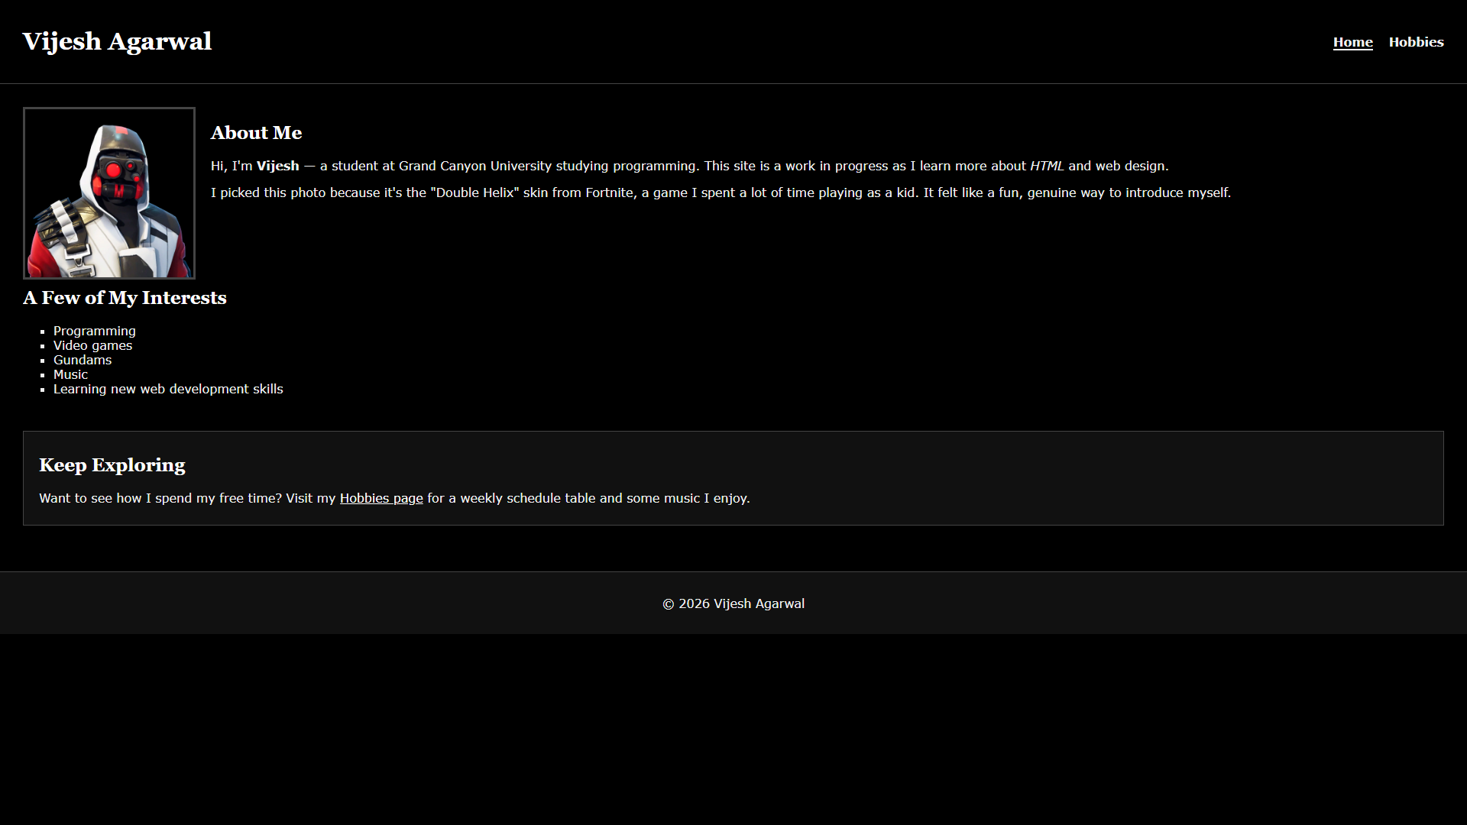Page 2: Hobbies (hobbies.html)
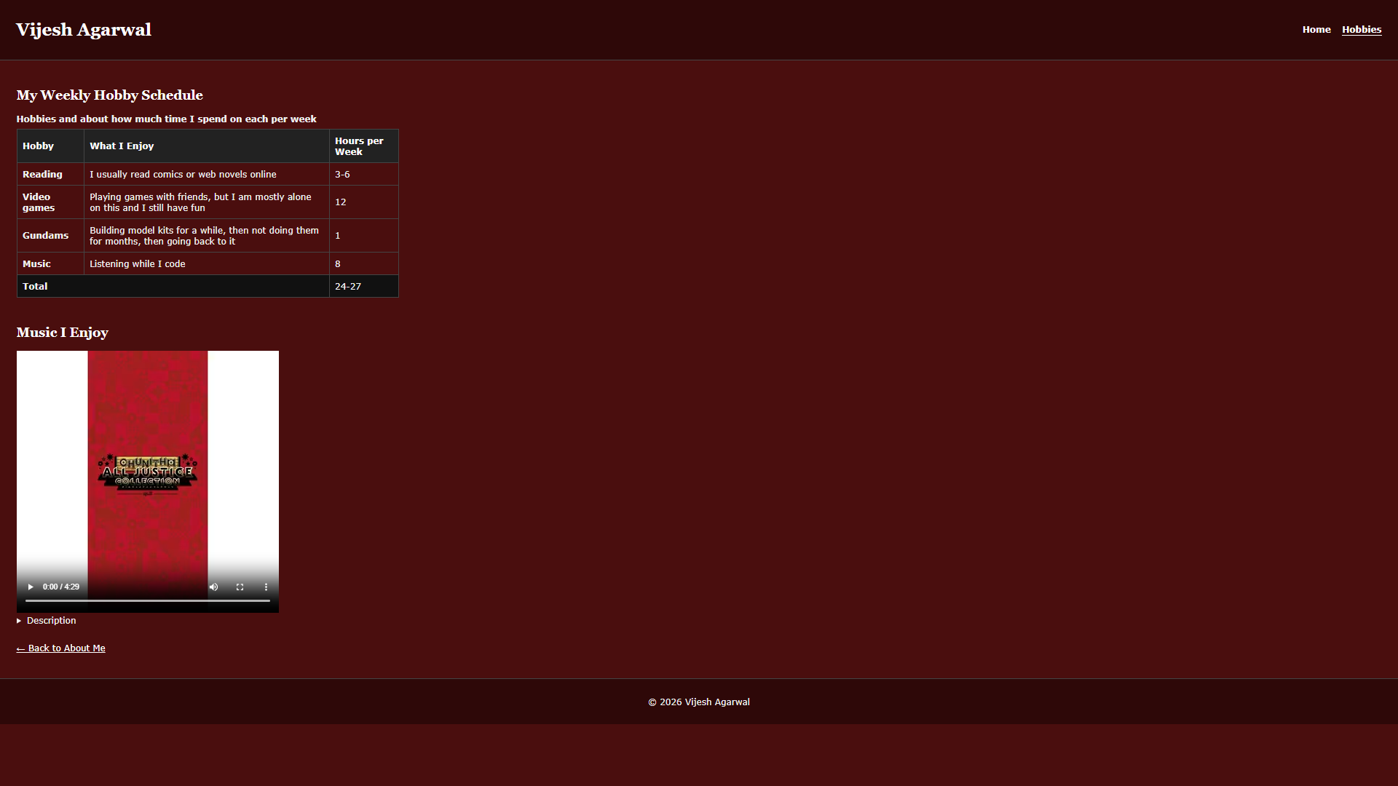

3. UI Sitemap
The site has two pages. Both share the same header, navigation, and footer, and they link to each other.
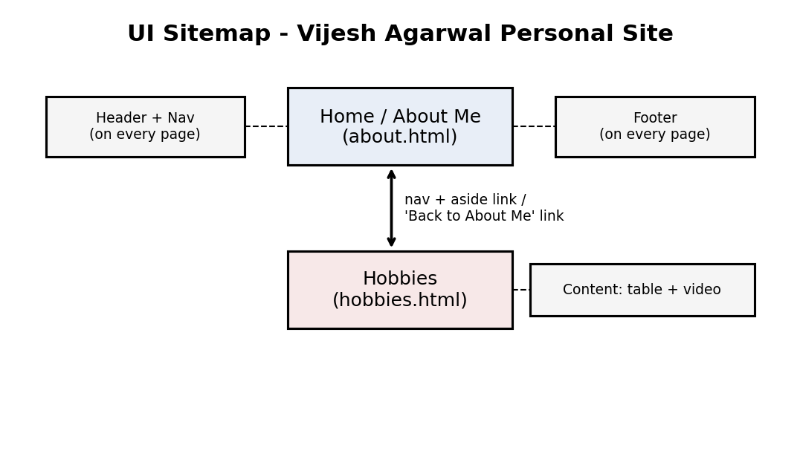

4. UI Wireframes (one per page, 2 pages = 2 wireframes)
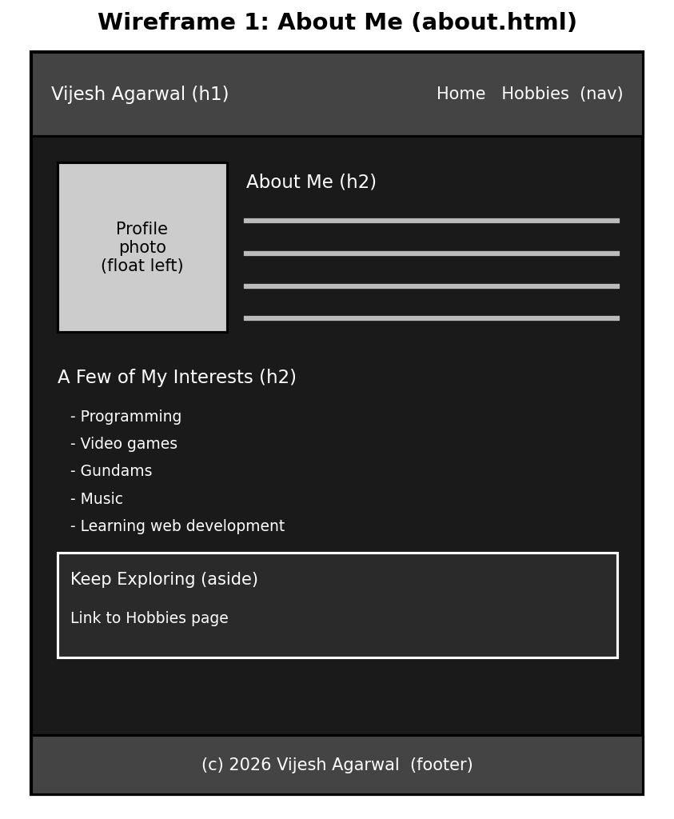

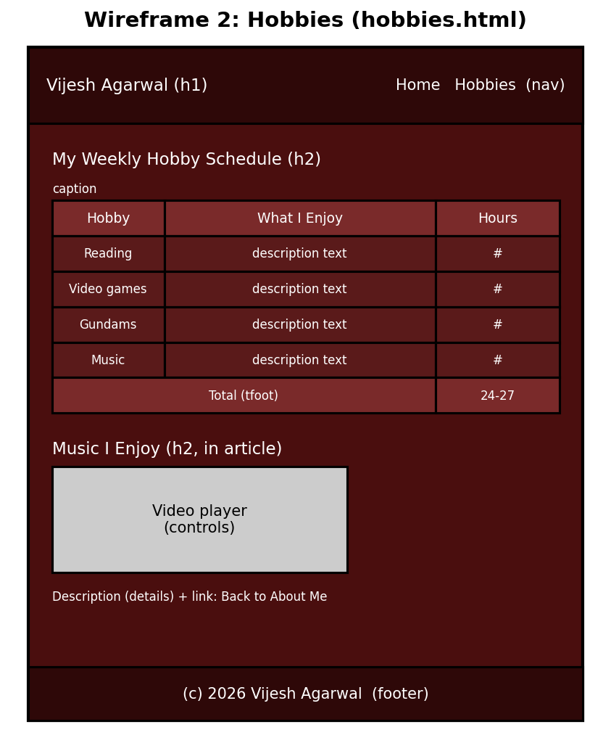

5. Annotated Code Snippets

5a. HTML table with accessibility comments (hobbies.html)
<!-- TABLE STRUCTURE (accessibility notes):
- <caption> names the table for screen readers
- <thead>, <tbody>, <tfoot> separate header, data, and total rows
- <th scope="col"> labels each column and <th scope="row"> labels
each row, so assistive technology reads each cell with its headings
- The wrapper div lets the table scroll sideways on small screens -->
<div class="table-wrap">
<table>
<caption>Hobbies and about how much time I spend on each per week</caption>
<thead>
<tr>
<th scope="col">Hobby</th>
<th scope="col">What I Enjoy</th>
<th scope="col">Hours per Week</th>
</tr>
</thead>
<tbody>
<tr>
<th scope="row">Reading</th>
<td>I usually read comics or web novels online</td>
<td>3-6</td>
</tr>
<!-- ...more rows... -->
</tbody>
<tfoot>
<tr>
<th scope="row" colspan="2">Total</th>
<td>24-27</td>
</tr>
</tfoot>
</table>
</div>
Explanation: The caption, scope attributes, and separate thead/tbody/tfoot sections let screen readers announce the right column and row heading for every cell.

5b. Anchor-based navigation (both pages)
<!-- NAV: same block on every page, with relative links. A consistent menu
helps visitors discover content and shows how the pages connect
(Connections). aria-current marks the page the visitor is on. -->
<nav aria-label="Main menu">
<a href="about.html" aria-current="page">Home</a>
<a href="hobbies.html">Hobbies</a>
</nav>
Explanation: Relative links keep the site portable, and the identical nav on every page means visitors always know where they are and how to reach the other page.

5c. Media tag with controls and description (hobbies.html)
<!-- MEDIA: xevel.mp4 is the song "Xevel (Platinum Long Ver.)" by Tatsh, which
I enjoy. It is not my own recording, so the rights belong to the artist;
it is used here for a class project only, with credit given. Controls let
the visitor choose when to play it; there is no autoplay. A text
description is provided below for people who cannot hear it. -->
<video controls width="480">
<source src="media/xevel.mp4" type="video/mp4">
Your browser does not support the video element.
<a href="#description">Read the description instead.</a>
</video>

<details id="description">
<summary>Description</summary>
<p>This video is the song "Xevel (Platinum Long Ver.)" by the artist
Tatsh, which I enjoy. It has sung vocals in English. The song is about
love, loss, and struggle during a time of war, and about holding on to
hope and not letting the light fade.</p>
</details>
Explanation: The video has visible controls and no autoplay. Because captions were not available for this file, a written description is provided as the transcript alternative, and the artist is credited as part of ethical sourcing. The lyrics were not copied.

6. Per-Page Annotations

About Me (about.html)
Curiosity: I experimented with floating the profile photo to the left so the text wraps beside it, and added a clear rule so my interests list starts below the photo instead of wrapping awkwardly.
Connections: The consistent navigation and the "Keep Exploring" aside link visitors from this page to my Hobbies page.
Creating Value: Visitors quickly learn who I am and what I care about, in a dark, readable layout that is easy on the eyes.
Christian worldview: Introducing myself honestly and organizing the page clearly is a way of serving visitors with integrity.

Hobbies (hobbies.html)
Curiosity: I tested wrapping the table so it scrolls sideways on small screens, and gave this page a dark red background to set it apart from the About page.
Connections: The same navigation, plus a "Back to About Me" link, ties this page to the rest of the site.
Creating Value: The table gives visitors a quick picture of how I spend my free time, and the video comes with a text description so everyone can understand it.
Christian worldview: I practiced stewardship by crediting the artist, Tatsh, and describing the song instead of copying its lyrics, and I made the media accessible to people who cannot hear it.

